**What is it User Story?**

* User stories represent the stockholders requirement inshortly informative way.
* The User stories are written by or for users to influence the functionality of the system being developed and the consist of three parts:

1. **Who** is for
2. **What** is expects from the system
3. **Why** it is important

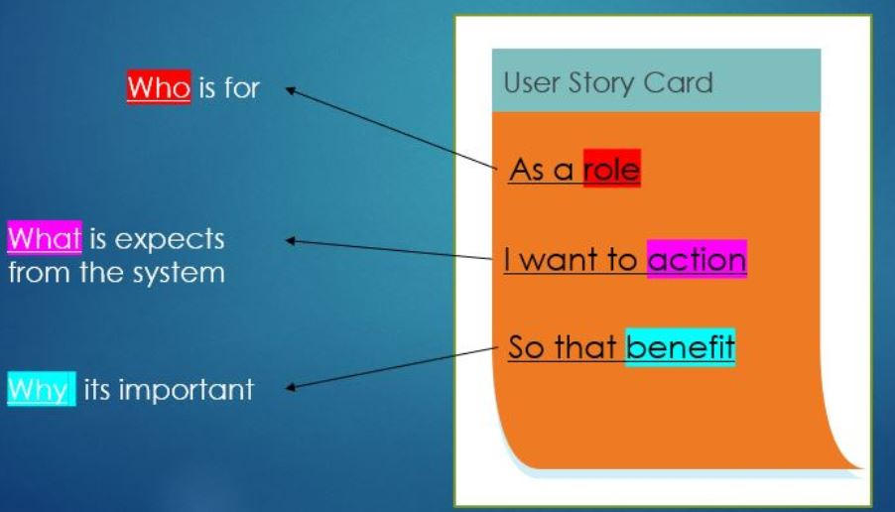

**User Story Quality:**

A high-quality user story should meet the following principles:

Independent

Uniform

Unambiguous

Minimal

Atomic

Well-formed

* **Well-formed:** It is required to be formulated in high quality and must include actor and method
* **Atomic:** The user story should be an atomic unit and represent no more than one method!
* **Minimal:** The user story should be short and clear
* **Unambiguous**: It is important that it be unambiguous and not open to interpretation. Therefore, we prefer to use nouns.
* **Uniform:** All user stories will be formulated according to the basic structure
* **Independent:** We would like that each User Story stand on its own and not depend on other User stories

